**PROJECT SUMMARY:**

Nilo’s Kitchen is an online food delivery system, which provides home made food to people in Mumbai. It is a perfect place for all the home made food lovers. Variety of Gujarati, Maharashtrian, South Indian, Italian, Continental, Mexican dishes are available at Nilo’s Kitchen.

Just place your order and enjoy the “Ma ka swad!”

**SCREENSHOTS OF SCREENS:**

**Home screen part 1:**

This is the Home Screen of “Nilo’s Kitchen”. The user can view the photographs of various dishes served at the kitchen. I have used bootstrap for the header and the carousel. The header contains the shopping basket where the user can view its basket and place the order.

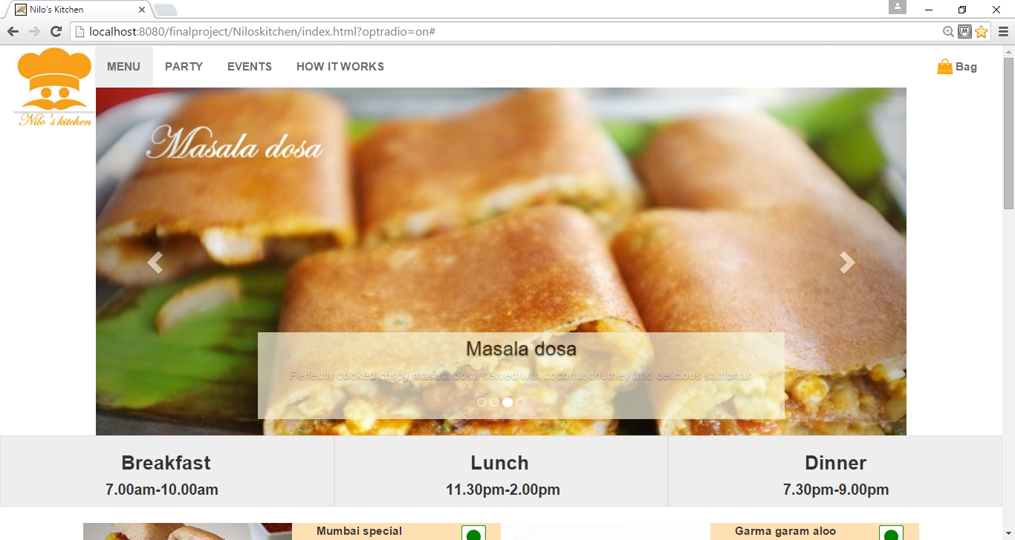

**Home screen part 2:**

This is the “Menu card” of Nilo’s Kitchen this week. Different items are available for breakfast, lunch and dinner. The user can view the details of the food items and choose an item.

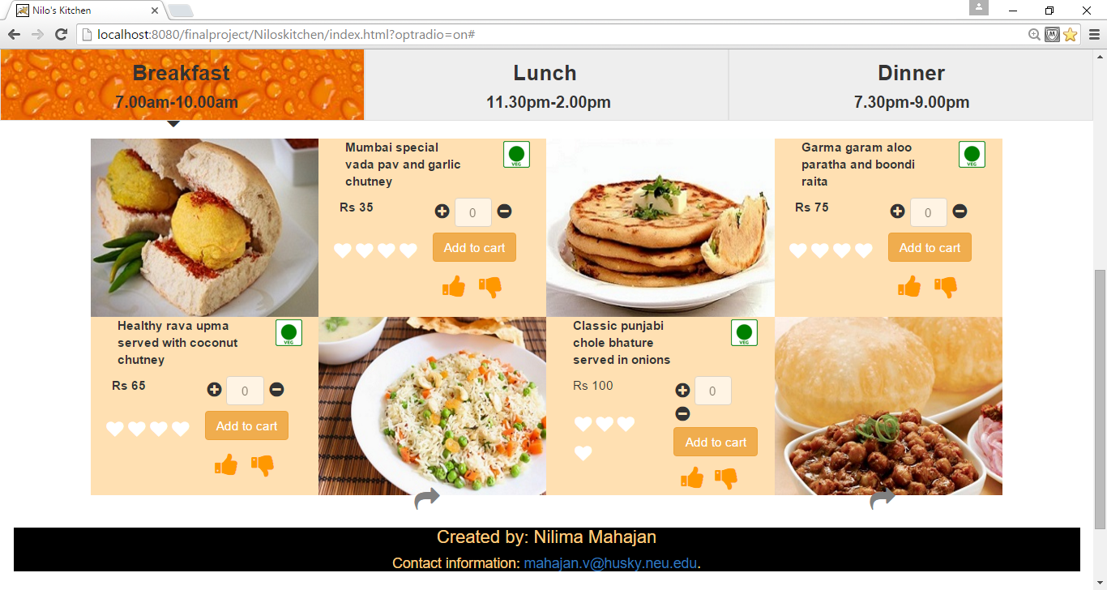

**Home screen part 3:**

The user can rate the food item by giving stars and can also like or dislike the item. The user can choose from the menu card and add the items to the cart.

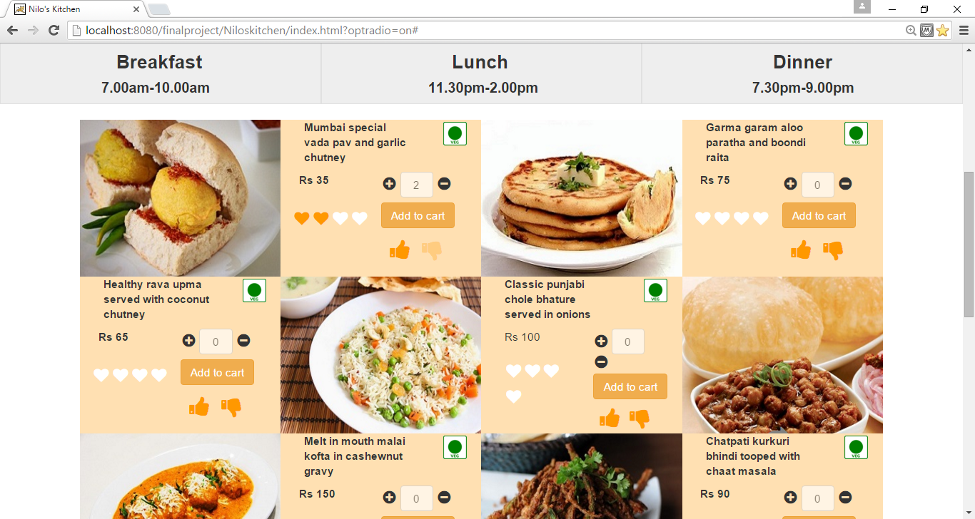

**Shopping cart order summary:**

Once the product is added to the cart, the user can now see the order summary. All the items choosen by the user are displayed in the cart and the order total is calculated. Also, if the user dismisses the cart and goes back to the menu and chooses the same item again, the cart gets updated with that item. On tapping the “Checkout option”, the user is navigated to the “Personal details” page.

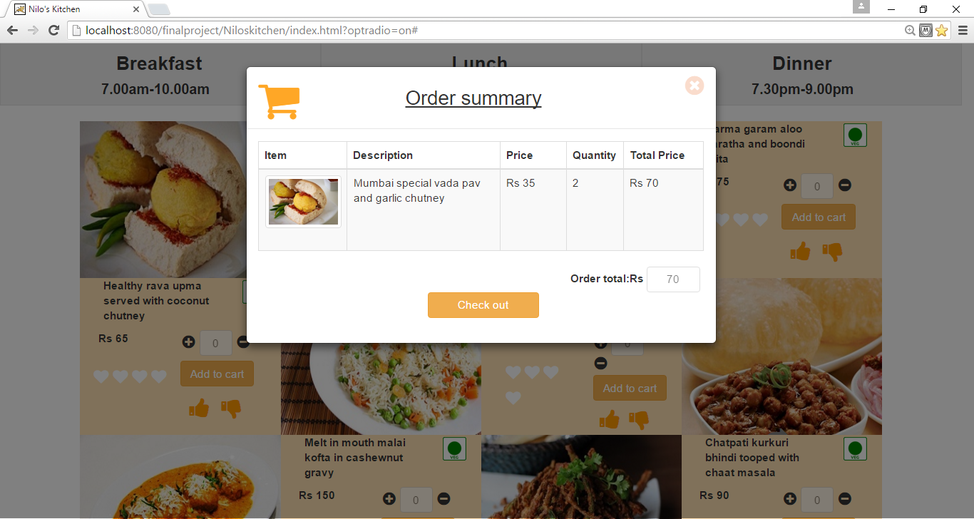

**Personal details:**

Here the user needs to enter his/her personal details for the food to be delivered to the correct address. Here, the fields are validated for ensuring that the user enters correct information. This client side validation is done using angular js. Also, when the user enters the zipcode, a list of zipcodes are populated and presented to the user. This list is fetched from the server side. Depending upon the zipcode, the state and city are populated. Once the user clicks on submit button, the payment gateway is opened.

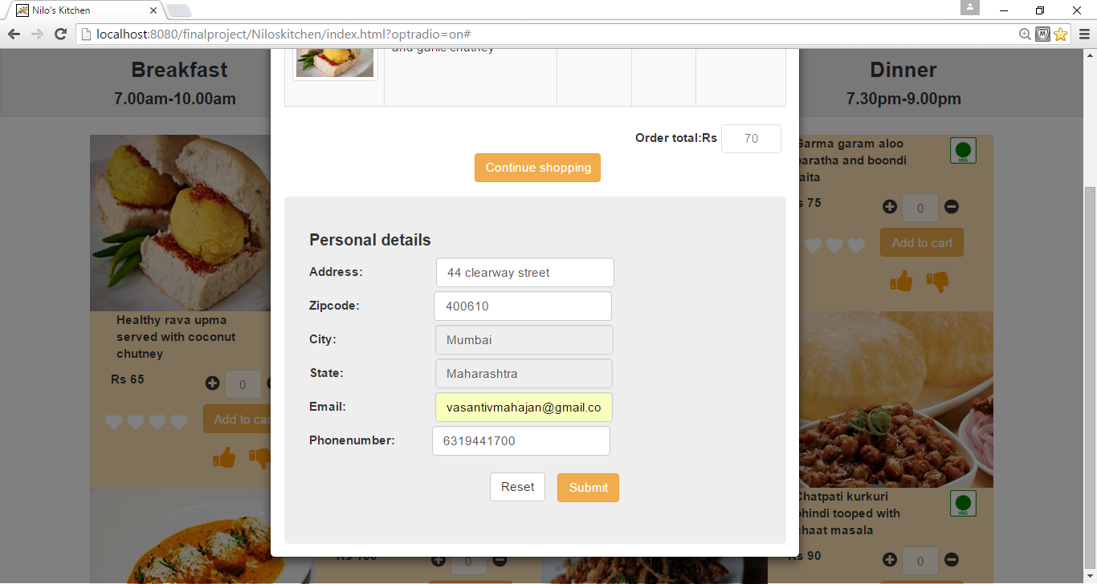

**Payment methods (Cash on delivery):**

The user can choose for cash on delivery or credit/debit card payment option. On choosing “COD”, the user needs to agree to the terms and conditions and then the order is placed.

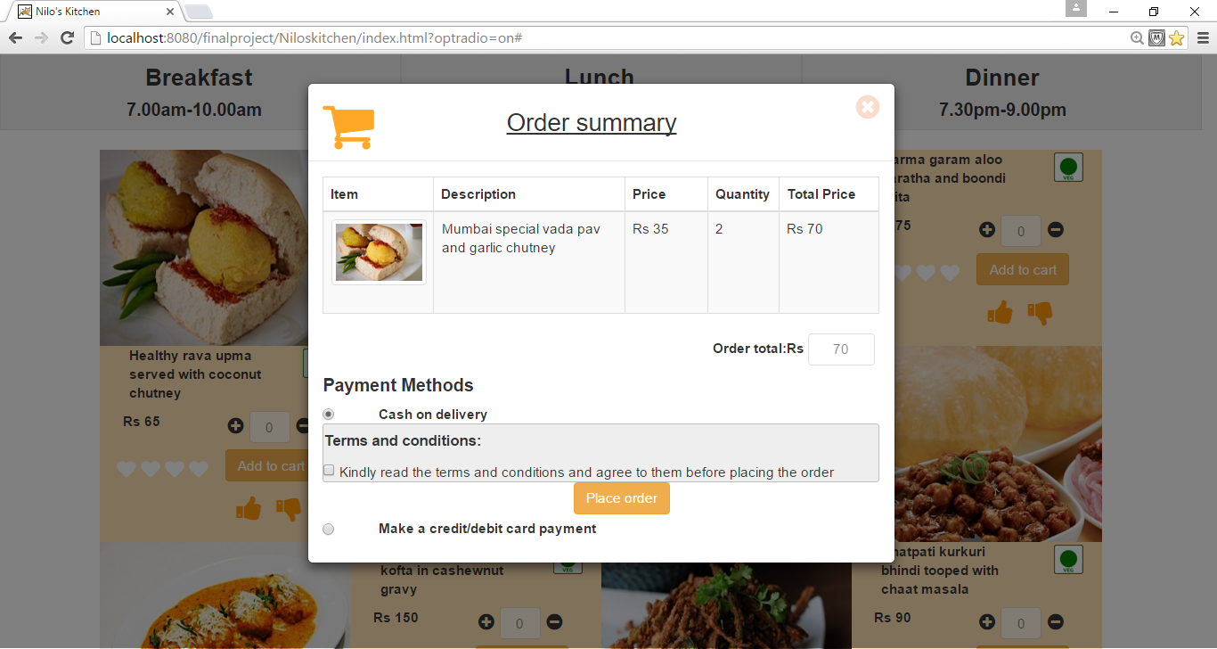

**Payment method (Credit/Debit card):**

On choosing Credit/Debit card option, the users is requested to enter the credit/debit card details. The form is validated using jQuery. Once the user clicks on the “Place order” button, the order is successfully placed.

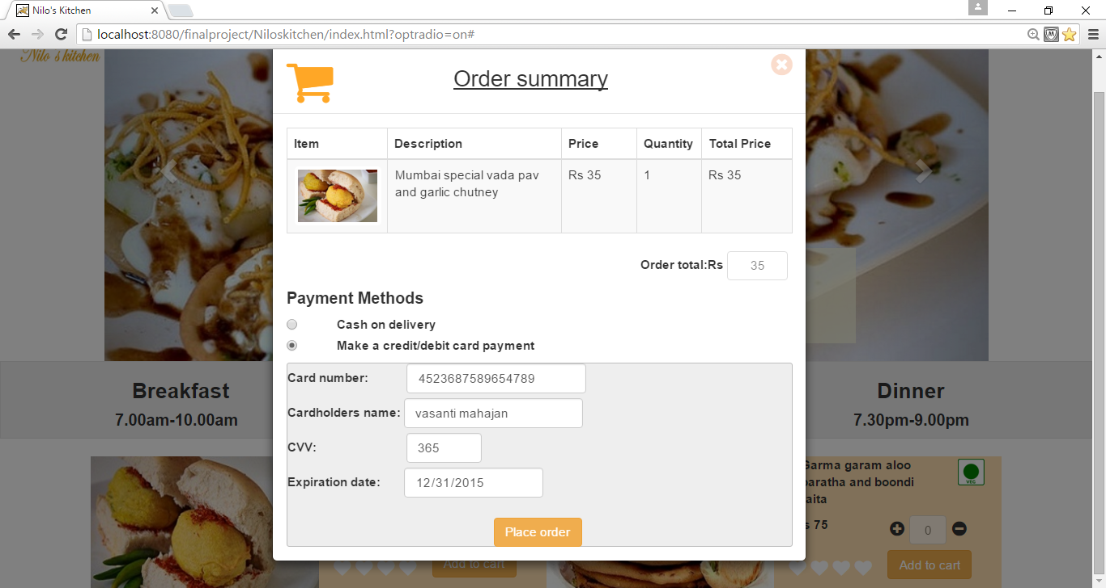

**Order confirmation page:**

Once the order is placed, the Confirmation screen is displayed.

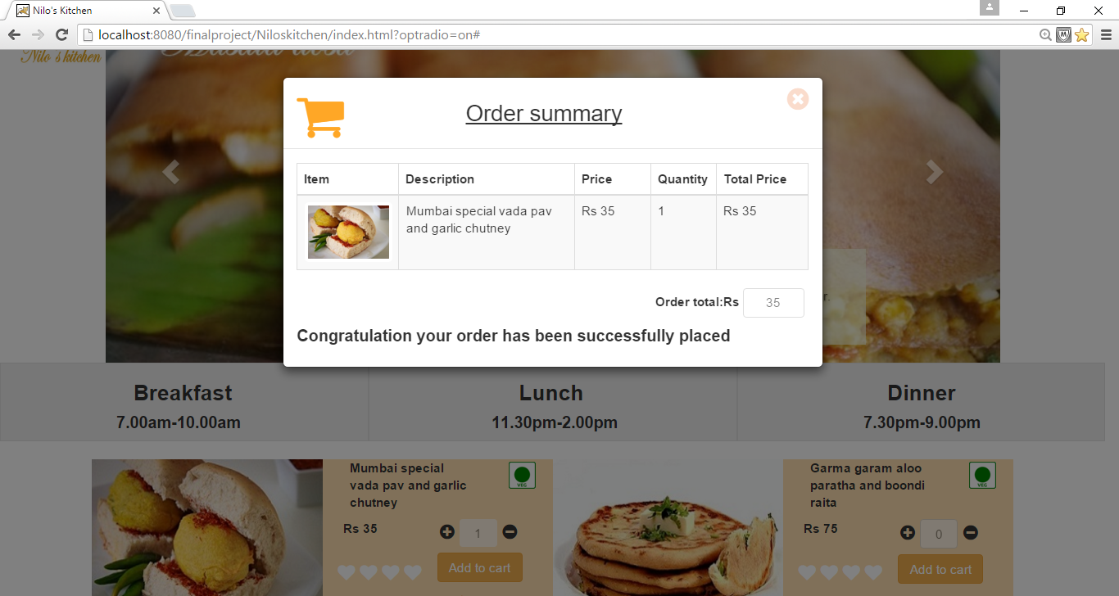

**HTML SOURCE CODE:**

**-index.html:**

<!DOCTYPE html>

<html lang="en">

<head>

<title>Nilo's Kitchen </title>

<meta charset="utf-8">

<meta name="viewport" content="width=device-width, initial-scale=1">

<link href="css/font-awesome.min.css" rel="stylesheet" type="text/css">

<link href="css/niloskitchen.css" rel="stylesheet" type="text/css">

<link rel="stylesheet" href="http://maxcdn.bootstrapcdn.com/bootstrap/3.3.5/css/bootstrap.min.css">

<link rel="stylesheet" href="https://maxcdn.bootstrapcdn.com/font-awesome/4.5.0/css/font-awesome.min.css">

<link href="css/tooltip-viewport.css" rel="stylesheet">

<script src="http://ajax.googleapis.com/ajax/libs/angularjs/1.4.8/angular.min.js"></script>

</head>

<body>

<div class="container-fluid"> <!--Beginning of container-->

<div class="row"> <!--Beginning of header row-->

<div class="col-lg-12 menubar">

<nav class="navbar navigationmenu">

<div class="navbar-header">

<button type="button" class="navbar-toggle" data-toggle="collapse" data-target="#myNavbar">

<span class="icon-bar"></span>

<span class="icon-bar"></span>

<span class="icon-bar"></span>

</button>

<img src="images/niloskitchenlogo.jpg" class="niloskitchenlogo img-responsive">

</div>

<div class="collapse navbar-collapse" id="myNavbar">

<ul class="nav navbar-nav menu">

<li><a href="#">MENU</a></li>

<li><a href="party.html">PARTY</a></li>

<li><a href="#">EVENTS</a></li>

<li><a href="#">HOW IT WORKS</a></li>

</ul>

<ul class="nav navbar-nav navbar-right">

<li><a href="#"><i class="fa fa-shopping-bag fa-lg" data-toggle="modal" data-target="#cartModal"></i> Bag</a></li>

</ul>

</div>

</nav>

</div>

</div> <!--End of header row-->

<div class="row"> <!--start of carousel-->

<div class="col-lg-1 col-md-1">

</div>

<div class="col-lg-10 col-md-10 carouseldiv">

<div id="myCarousel" class="carousel slide" data-ride="carousel">

<!-- Indicators -->

<ol class="carousel-indicators">

<li data-target="#myCarousel" data-slide-to="0" class="active"></li>

<li data-target="#myCarousel" data-slide-to="1"></li>

<li data-target="#myCarousel" data-slide-to="2"></li>

<li data-target="#myCarousel" data-slide-to="3"></li>

</ol>

<!-- Wrapper for slides -->

<div class="carousel-inner" role="listbox">

<div class="item active">

<img src="images/slider/caraousel_image1.jpg" class="img-responsive" alt="carousalimage">

<div class="carousel-caption">

<h3>Papdi chaat</h3>

<p>Revive your tastebuds by tasting our delicious chatpata chaat.

</p>

</div>

</div>

<div class="item">

<img src="images/slider/caraousel_image2.jpg" class="img-responsive" alt="carousalimage">

<div class="carousel-caption">

<h3>Chole Bhatura</h3>

<p>The very famous north indian breakfast dish, garma garam chole served with soft bhatura. Served with onions and pickle will make your day</p>

</div>

</div>

<div class="item">

<img src="images/slider/caraousel_image3.jpg" class="img-responsive" alt="carousalimage" >

<div class="carousel-caption">

<h3>Masala dosa</h3>

<p>Perfectly cooked crispy masala dosa served with coconut chutney and delicious sambhar.</p>

</div>

</div>

<div class="item">

<img src="images/slider/caraousel_image4.jpg" class="img-responsive" alt="carousalimage">

<div class="carousel-caption">

<h3>Paneer butter masala</h3>

<p>Perfectly cooked melt in mouth paneer, cooked with cashewnut gravy.</p>

</div>

</div>

</div>

<!-- Left and right controls -->

<a class="left carousel-control" href="#myCarousel" role="button" data-slide="prev">

<span class="glyphicon glyphicon-chevron-left" aria-hidden="true"></span>

<span class="sr-only">Previous</span>

</a>

<a class="right carousel-control" href="#myCarousel" role="button" data-slide="next">

<span class="glyphicon glyphicon-chevron-right" aria-hidden="true"></span>

<span class="sr-only">Next</span>

</a>

</div>

</div>

<div class="col-lg-1 col-md-1">

</div>

</div> <!--end of caraousel-->

<div class="row"> <!--start of meals-->

<div class="col-lg-4 col-md-4 col-sm-4 col-xs-4 breakfastmenu">

<h3>Breakfast</h3>

<h4>7.00am-10.00am</h4>

</div>

<div class="col-lg-4 col-md-4 col-sm-4 col-xs-4 lunchmenu">

<h3>Lunch</h3>

<h4>11.30pm-2.00pm</h4>

</div>

<div class="col-lg-4 col-md-4 col-sm-4 col-xs-4 dinnermenu">

<h3>Dinner</h3>

<h4>7.30pm-9.00pm</h4>

</div>

</div> <!--end of meals-->

<span><i class="fa fa-caret-down fa-3x breakfastcaret"></i></span>

<span><i class="fa fa-caret-down fa-3x lunchcaret"></i></span>

<span><i class="fa fa-caret-down fa-3x dinnercaret"></i></span>

<div class="row"> <!--start of menu-->

<div class="col-lg-1 ">

</div>

<div class="col-lg-10 menufororder">

<div class="row breakfastrows">

<div class="section1">

<div class="col-lg-3 col-md-3 col-sm-6 col-xs-12 imagesection">

<img src="images/menuimage/breakfastimage2.jpg" class=" itemimage" alt=""/>

<span><i class="fa fa-share fa-2x moreinformation"></i></span>

</div>

<div class="col-lg-3 col-md-3 col-sm-6 col-xs-12 contentsection">

<div class="col-lg-12 col-md-12 col-sm-12 col-xs-12">

<div class="col-lg-9 col-md-9 col-sm-9 col-xs-9">

<p>Mumbai special vada pav and garlic chutney</p>

</div>

<div class="col-lg-3 col-md-3 col-sm-3 col-xs-3 vegmark">

<img src="images/menuimage/vegmark.png" class="img-responsive" id="vegmark" alt="vegmark"/>

</div>

</div>

<div class="col-lg-12 col-md-12 col-sm-12 col-xs-12 rate">

<div class="col-lg-6 col-md-6 col-sm-6 col-xs-6 ">

<p>Rs 35</p>

<span id="hearts"> <i class="fa fa-heart fa-lg likeheart" style="color:white;" onClick="colourheart(this)"></i> <i class="fa fa-heart fa-lg likeheart" style="color:white;" onClick="colourheart(this)"></i> <i class="fa fa-heart fa-lg likeheart" style="color:white;" onClick="colourheart(this)"></i> <i class="fa fa-heart likeheart fa-lg" style="color:white;" onClick="colourheart(this)"></i>

</span>

</div>

<div class="col-lg-6 col-md-6 col-sm-6 col-xs-6 " id="cart">

<i class="fa fa-plus-circle fa-lg"></i>

<input type="text" class="btn btn-default quantity" value="0" disabled>

<i class="fa fa-minus-circle fa-lg"></i>

<button type="submit" class="btn btn-warning addToCart" >Add to cart</button>

<span><i class="fa fa-thumbs-up fa-2x" onClick="thumbsUp(this)"></i> <i class="fa fa-thumbs-down fa-2x"></i></span>

</div>

</div>

</div>

</div>

<div class="section2" >

<div class="col-lg-3 col-md-3 col-sm-6 col-xs-12 imagesection">

<img src="images/menuimage/breakfastimage1.jpg" class=" itemimage" alt=""/>

<span><i class="fa fa-share fa-2x moreinformation"></i></span>

</div>

<div class="col-lg-3 col-md-3 col-sm-6 col-xs-12 contentsection">

<div class="col-lg-12 col-md-12 col-sm-12 col-xs-12 ">

<div class="col-lg-9 col-md-9 col-sm-9 col-xs-9">

<p> Garma garam aloo paratha and boondi raita</p>

</div>

<div class="col-lg-3 col-md-3 col-sm-3 col-xs-3 vegmark">

<img src="images/menuimage/vegmark.png" class="img-responsive" id="vegmark" alt="vegmark"/>

</div>

</div>

<div class="col-lg-12 col-md-12 col-sm-12 col-xs-12 rate">

<div class="col-lg-6 col-md-6 col-sm-6 col-xs-6 ">

<p>Rs 75</p>

<!--<img src="images/menuimage/chef.png" alt="chefslogo" id="chefslogo1" class=" img-circle"/>-->

<span id="hearts"> <i class="fa fa-heart likeheart fa-lg" style="color:white;" onClick="colourheart(this)"></i> <i class="fa fa-heart likeheart fa-lg" style="color:white;" onClick="colourheart(this)"></i> <i class="fa fa-heart likeheart fa-lg" style="color:white;" onClick="colourheart(this)"></i> <i class="fa fa-heart likeheart fa-lg" style="color:white;" onClick="colourheart(this)"></i>

</span>

</div>

<div class="col-lg-6 col-md-6 col-sm-6 col-xs-6" id="cart">

<i class="fa fa-plus-circle fa-lg"></i>

<input type="text" class="btn btn-default quantity" value="0" disabled>

<i class="fa fa-minus-circle fa-lg"></i>

<button type="submit" class="btn btn-warning addToCart" >Add to cart</button><br />

<span><i class="fa fa-thumbs-up fa-2x"></i> <i class="fa fa-thumbs-down fa-2x"></i></span>

</div>

</div>

</div>

</div>

</div>

<div class="row breakfastrows">

<div class="section1">

<div class="col-lg-3 col-md-3 col-sm-6 col-xs-12 contentsection">

<div class="col-lg-12 col-md-12 col-sm-12 col-xs-12 ">

<div class="col-lg-9 col-md-9 col-sm-9 col-xs-9" >

<p>Healthy rava upma served with coconut chutney </p>

</div>

<div class="col-lg-3 col-md-3 col-sm-3 col-xs-3 vegmark">

<img src="images/menuimage/vegmark.png" id="vegmark" alt="vegmark"/>

</div>

</div>

<div class="col-lg-12 col-md-12 col-sm-12 col-xs-12 rate">

<div class="col-lg-6 col-md-6 col-sm-6 col-xs-6 ">

<p>Rs 65</p>

<span id="hearts"><i class="fa fa-heart likeheart fa-lg" style="color:white;" onClick="colourheart(this)"></i><i class="fa fa- heart likeheart fa-lg" style="color:white;" onClick="colourheart(this)"></i> <i class="fa fa-heart likeheart fa-lg" style="color:white;" onClick="colourheart(this)"></i> <i class="fa fa-heart likeheart fa-lg" style="color:white;" onClick="colourheart(this)"></i> <i class="fa fa-heart likeheart fa-lg" style="color:white;" onClick="colourheart(this)"></i>

</span>

</div>

<div class="col-lg-6 col-md-6 col-sm-6 col-xs-6" id="cart">

<i class="fa fa-plus-circle fa-lg"></i>

<input type="text" class="btn btn-default quantity" value="0" disabled>

<i class="fa fa-minus-circle fa-lg"></i>

<button type="submit" class="btn btn-warning addToCart">Add to cart</button>

<span><i class="fa fa-thumbs-up fa-2x"></i> <i class="fa fa-thumbs-down fa-2x"></i></span>

</div>

</div>

</div>

<div class="col-lg-3 col-md-3 col-sm-6 col-xs-12 imagesection">

<img src="images/menuimage/dinnerimage4.JPG" class=" itemimage" alt=""/>

<span><i class="fa fa-share fa-2x moreinformation"></i></span>

</div>

</div>

<div class="section2">

<div class="col-lg-3 col-md-3 col-sm-6 col-xs-12 contentsection">

<div class="col-lg-12 col-md-12 col-sm-12 col-xs-12 ">

<div class="col-lg-9 col-md-9 col-sm-9 col-xs-9">

<p>Classic punjabi chole bhature served in onions </p>

</div>

<div class="col-lg-3 col-md-3 col-sm-3 col-xs-3 vegmark">

<img src="images/menuimage/vegmark.png" id="vegmark" alt="vegmark"/>

</div>

</div>

<div class="col-lg-12 col-md-12 col-sm-12 col-xs-12rate">

<div class="col-lg-6 col-md-6 col-sm-6 col-xs-6">

<p>Rs 100</p>

<span id="hearts"><i class="fa fa-heart likeheart fa-lg" style="color:white;" onClick="colourheart(this)"></i><i class="fa fa- heart likeheart fa-lg" style="color:white;" onClick="colourheart(this)"></i> <i class="fa fa-heart likeheart fa-lg" style="color:white;" onClick="colourheart(this)"></i> <i class="fa fa-heart likeheart fa-lg" style="color:white;" onClick="colourheart(this)"></i> <i class="fa fa-heart likeheart fa-lg" style="color:white;" onClick="colourheart(this)"></i>

</span>

</div>

<div class="col-lg-6 col-md-6 col-sm-6 col-xs-6" id="cart">

<i class="fa fa-plus-circle fa-lg"></i>

<input type="text" class="btn btn-default quantity" value="0" disabled>

<i class="fa fa-minus-circle fa-lg"></i>

<button type="submit" class="btn btn-warning addToCart" >Add to cart</button>

<span><i class="fa fa-thumbs-up fa-2x"></i> <i class="fa fa-thumbs-down fa-2x"></i></span>

</div>

</div>

</div>

<div class="col-lg-3 col-md-3 col-sm-6 col-xs-12 imagesection">

<img src="images/menuimage/breakfastimage4.jpg" class=" itemimage" alt=""/>

<span><i class="fa fa-share fa-2x moreinformation"></i></span>

</div>

</div>

</div>

<div class="row lunchrows">

<div class="section1">

<div class="col-lg-3 col-md-3 col-sm-6 col-xs-12 imagesection" >

<img src="images/menuimage/lunchimage1.jpg" class=" itemimage" alt=""/>

<span><i class="fa fa-share fa-2x moreinformation"></i></span>

</div>

<div class="col-lg-3 col-md-3 col-sm-6 col-xs-12 contentsection">

<div class="col-lg-12 col-md-12 col-sm-12 col-xs-12 ">

<div class="col-lg-9 col-md-9 col-sm-9 col-xs-9">

<p>Melt in mouth malai kofta in cashewnut gravy</p>

</div>

<div class="col-lg-3 col-md-3 col-sm-3 col-xs-3 vegmark">

<img src="images/menuimage/vegmark.png" class="img-responsive" id="vegmark" alt="vegmark"/>

</div>

</div>

<div class="col-lg-12 col-md-12 col-sm-12 col-xs-12 rate">

<div class="col-lg-6 col-md-6 col-sm-6 col-xs-6 ">

<p>Rs 150</p>

<span id="hearts"><i class="fa fa-heart likeheart fa-lg" style="color:white;" onClick="colourheart(this)"></i><i class="fa fa- heart likeheart fa-lg" style="color:white;" onClick="colourheart(this)"></i> <i class="fa fa-heart likeheart fa-lg" style="color:white;" onClick="colourheart(this)"></i> <i class="fa fa-heart likeheart fa-lg" style="color:white;" onClick="colourheart(this)"></i> <i class="fa fa-heart likeheart fa-lg" style="color:white;" onClick="colourheart(this)"></i>

</span>

</div>

<div class="col-lg-6 col-md-6 col-sm-6 col-xs-6" id="cart">

<i class="fa fa-plus-circle fa-lg"></i>

<input type="text" class="btn btn-default quantity" value="0" disabled>

<i class="fa fa-minus-circle fa-lg"></i>

<button type="submit" class="btn btn-warning addToCart" >Add to cart</button>

<span><i class="fa fa-thumbs-up fa-2x"></i> <i class="fa fa-thumbs-down fa-2x"></i></span>

</div>

</div>

</div>

</div>

<div class="section2">

<div class="col-lg-3 col-md-3 col-sm-6 col-xs-12 imagesection">

<img src="images/menuimage/lunchimage2.jpg" class=" itemimage" alt=""/>

<span><i class="fa fa-share fa-2x moreinformation"></i></span>

</div>

<div class="col-lg-3 col-md-3 col-sm-6 col-xs-12 contentsection">

<div class="col-lg-12 col-md-12 col-sm-12 col-xs-12">

<div class="col-lg-9 col-md-9 col-sm-9 col-xs-9">

<p>Chatpati kurkuri bhindi tooped with chaat masala </p>

</div>

<div class="col-lg-3 col-md-3 col-sm-3 col-xs-3 vegmark">

<img src="images/menuimage/vegmark.png" class="img-responsive" id="vegmark" alt="vegmark"/>

</div>

</div>

<div class="col-lg-12 col-md-12 col-sm-12 col-xs-12 rate">

<div class="col-lg-6 col-md-6 col-sm-6 col-xs-6">

<p>Rs 90</p>

<span id="hearts"><i class="fa fa-heart likeheart fa-lg" style="color:white;" onClick="colourheart(this)"></i><i class="fa fa- heart likeheart fa-lg" style="color:white;" onClick="colourheart(this)"></i> <i class="fa fa-heart likeheart fa-lg" style="color:white;" onClick="colourheart(this)"></i> <i class="fa fa-heart likeheart fa-lg" style="color:white;" onClick="colourheart(this)"></i> <i class="fa fa-heart likeheart fa-lg" style="color:white;" onClick="colourheart(this)"></i>

</span>

</div>

<div class="col-lg-6 col-md-6 col-sm-6 col-xs-6" id="cart">

<i class="fa fa-plus-circle fa-lg"></i>

<input type="text" class="btn btn-default quantity" value="0" disabled>

<i class="fa fa-minus-circle fa-lg"></i>

<button type="submit" class="btn btn-warning addToCart">Add to cart</button>

<span><i class="fa fa-thumbs-up fa-2x"></i> <i class="fa fa-thumbs-down fa-2x"></i></span>

</div>

</div>

</div>

</div>

</div>

<div class="row lunchrows lunchrow2">

<div class="section1">

<div class="col-lg-3 col-md-3 col-sm-6 col-xs-12 contentsection">

<div class="col-lg-12 col-md-12 col-sm-12 col-xs-12">

<div class="col-lg-9 col-md-9 col-sm-9 col-xs-9">

<p>Spicy paneer tikka masala with naan and roti </p>

</div>

<div class="col-lg-3 col-md-3 col-sm-3 col-xs-3 vegmark">

<img src="images/menuimage/vegmark.png" class="img-responsive" id="vegmark" alt="vegmark"/>

</div>

</div>

<div class="col-lg-12 col-md-12 col-sm-12 col-xs-12 rate">

<div class="col-lg-6 col-md-6 col-sm-6 col-xs-6 ">

<p>Rs 175</p>

<span id="hearts"><i class="fa fa-heart likeheart fa-lg" style="color:white;" onClick="colourheart(this)"></i><i class="fa fa- heart likeheart fa-lg" style="color:white;" onClick="colourheart(this)"></i> <i class="fa fa-heart likeheart fa-lg" style="color:white;" onClick="colourheart(this)"></i> <i class="fa fa-heart likeheart fa-lg" style="color:white;" onClick="colourheart(this)"></i> <i class="fa fa-heart likeheart fa-lg" style="color:white;" onClick="colourheart(this)"></i>

</span>

</div>

<div class="col-lg-6 col-md-6 col-sm-6 col-xs-6" id="cart">

<i class="fa fa-plus-circle fa-lg"></i>

<input type="text" class="btn btn-default quantity" value="0" disabled>

<i class="fa fa-minus-circle fa-lg"></i>

<button type="submit" class="btn btn-warning addToCart" >Add to cart</button>

<span><i class="fa fa-thumbs-up fa-2x"></i> <i class="fa fa-thumbs-down fa-2x"></i></span>

</div>

</div>

</div>

<div class="col-lg-3 col-md-3 col-sm-6 col-xs-12 imagesection">

<img src="images/menuimage/lunchimage3.jpg" class=" itemimage" alt=""/>

<span><i class="fa fa-share fa-2x moreinformation"></i></span>

</div>

</div>

<div class="section2">

<div class="col-lg-3 col-md-3 col-sm-6 col-xs-12 contentsection">

<div class="col-lg-12 col-md-12 col-sm-12 col-xs-12">

<div class="col-lg-9 col-md-9 col-sm-9 col-xs-9">

<p>Dry aloo, jira,onion sabji cooked to perfection</p>

</div>

<div class="col-lg-3 col-md-3 col-sm-3 col-xs-3 vegmark">

<img src="images/menuimage/vegmark.png" class="img-responsive" id="vegmark" alt="vegmark"/>

</div>

</div>

<div class="col-lg-12 col-md-12 coml-sm-12 col-xs-12 rate">

<div class="col-lg-6 col-md-6 col-sm-6 col-xs-6">

<p>Rs 100</p>

<!--<img src="images/menuimage/chef.png" alt="chefslogo" id="chefslogo1" class=" img-circle"/>-->

<span id="hearts"><i class="fa fa-heart likeheart fa-lg" style="color:white;" onClick="colourheart(this)"></i><i class="fa fa- heart likeheart fa-lg" style="color:white;" onClick="colourheart(this)"></i> <i class="fa fa-heart likeheart fa-lg" style="color:white;" onClick="colourheart(this)"></i> <i class="fa fa-heart likeheart fa-lg" style="color:white;" onClick="colourheart(this)"></i> <i class="fa fa-heart likeheart fa-lg" style="color:white;" onClick="colourheart(this)"></i>

</span>

</div>

<div class="col-lg-6 col-md-6 col-sm-6 col-xs-6" id="cart">

<i class="fa fa-plus-circle fa-lg"></i>

<input type="text" class="btn btn-default quantity" value="0" disabled>

<i class="fa fa-minus-circle fa-lg"></i>

<button type="submit" class="btn btn-warning addToCart" >Add to cart</button>

<span><i class="fa fa-thumbs-up fa-2x"></i> <i class="fa fa-thumbs-down fa-2x"></i></span>

</div>

</div>

</div>

<div class="col-lg-3 col-md-3 col-sm-6 col-xs-12 imagesection">

<img src="images/menuimage/lunchimage4.jpg" class=" itemimage" alt=""/>

<span><i class="fa fa-share fa-2x moreinformation"></i></span>

</div>

</div>

</div>

<div class="row dinnerrows">

<div class="section1">

<div class="col-lg-3 col-md-3 col-sm-6 col-xs-12 imagesection">

<img src="images/menuimage/dinnerimage1.jpg" class=" itemimage" alt=""/>

<span><i class="fa fa-share fa-2x moreinformation"></i></span>

</div>

<div class="col-lg-3 col-md-3 col-sm-6 col-xs-12 contentsection">

<div class="col-lg-12 col-md-12 col-sm-12 col-xs-12">

<div class="col-lg-9 col-md-9 col-sm-9 col-xs-9">

<p>Vegetable dum biriyani served withboondi raita</p>

</div>

<div class="col-lg-3 col-md-3 col-sm-3 col-xs-3 vegmark">

<img src="images/menuimage/vegmark.png" class="img-responsive" id="vegmark" alt="vegmark"/>

</div>

</div>

<div class="col-lg-12 col-md-12 col-sm-12 col-xs-12 rate">

<div class="col-lg-6 col-md-6 col-sm-6 col-xs-6">

<p>Rs 125</p>

<span id="hearts"><i class="fa fa-heart likeheart fa-lg" style="color:white;" onClick="colourheart(this)"></i><i class="fa fa- heart likeheart fa-lg" style="color:white;" onClick="colourheart(this)"></i> <i class="fa fa-heart likeheart fa-lg" style="color:white;" onClick="colourheart(this)"></i> <i class="fa fa-heart likeheart fa-lg" style="color:white;" onClick="colourheart(this)"></i> <i class="fa fa-heart likeheart fa-lg" style="color:white;" onClick="colourheart(this)"></i>

</span>

</div>

<div class="col-lg-6 col-md-6 col-sm-6 col-xs-6" id="cart">

<i class="fa fa-plus-circle fa-lg"></i>

<input type="text" class="btn btn-default quantity" value="0" disabled>

<i class="fa fa-minus-circle fa-lg"></i>

<button type="submit" class="btn btn-warning addToCart">Add to cart</button>

<span><i class="fa fa-thumbs-up fa-2x"></i> <i class="fa fa-thumbs-down fa-2x"></i></span>

</div>

</div>

</div>

</div>

<div class="section2">

<div class="col-lg-3 col-md-3 col-sm-6 col-xs-12 imagesection">

<img src="images/menuimage/dinnerimage2.jpg" class=" itemimage" alt=""/>

<span><i class="fa fa-share fa-2x moreinformation"></i></span>

</div>

<div class="col-lg-3 col-md-3 col-sm-6 col-xs-12 contentsection">

<div class="col-lg-12 col-md-12 col-sm-12 col-xs-12">

<div class="col-lg-9 col-md-9 col-sm-9 col-xs-9">

<p>Mouth watering, Indianised chinese hakka noodle</p>

</div>

<div class="col-lg-3 col-md-3 col-sm-3 vegmark">

<img src="images/menuimage/vegmark.png" class="img-responsive" id="vegmark" alt="vegmark"/>

</div>

</div>

<div class="col-lg-12 col-md-12 col-sm-12 col-xs-12 rate">

<div class="col-lg-6 col-md-6 col-sm-6 col-xs-6">

<p>Rs 75</p>

<span id="hearts"><i class="fa fa-heart likeheart fa-lg" style="color:white;" onClick="colourheart(this)"></i><i class="fa fa- heart likeheart fa-lg" style="color:white;" onClick="colourheart(this)"></i> <i class="fa fa-heart likeheart fa-lg" style="color:white;" onClick="colourheart(this)"></i> <i class="fa fa-heart likeheart fa-lg" style="color:white;" onClick="colourheart(this)"></i> <i class="fa fa-heart likeheart fa-lg" style="color:white;" onClick="colourheart(this)"></i>

</span>

</div>

<div class="col-lg-6 col-md-6 col-sm-6 col-xs-6" id="cart">

<i class="fa fa-plus-circle fa-lg"></i>

<input type="text" class="btn btn-default quantity" value="0" disabled>

<i class="fa fa-minus-circle fa-lg"></i>

<button type="submit" class="btn btn-warning addToCart" >Add to cart</button>

<span><i class="fa fa-thumbs-up fa-2x"></i> <i class="fa fa-thumbs-down fa-2x"></i></span>

</div>

</div>

</div>

</div>

</div>

<div class="row dinnerrows dinnerrows2">

<div class="section1">

<div class="col-lg-3 col-md-3 col-sm-6 col-xs-12 contentsection">

<div class="col-lg-12 col-md-12 col-sm-12 col-xs-12">

<div class="col-lg-9 col-md-9 col-sm-9 col-xs-9">

<p>Mumbai's loved item pavbhaji in amul butter </p>

</div>

<div class="col-lg-3 col-md-3 col-sm-3 col-xs-3 vegmark">

<img src="images/menuimage/vegmark.png" class="img-responsive" id="vegmark" alt="vegmark"/>

</div>

</div>

<div class="col-lg-12 col-md-12 col-sm-12 col-xs-12 rate">

<div class="col-lg-6 col-md-6 col-sm-6 col-xs-6">

<p>Rs 85</p>

<span id="hearts"><i class="fa fa-heart likeheart fa-lg" style="color:white;" onClick="colourheart(this)"></i><i class="fa fa- heart likeheart fa-lg" style="color:white;" onClick="colourheart(this)"></i> <i class="fa fa-heart likeheart fa-lg" style="color:white;" onClick="colourheart(this)"></i> <i class="fa fa-heart likeheart fa-lg" style="color:white;" onClick="colourheart(this)"></i> <i class="fa fa-heart likeheart fa-lg" style="color:white;" onClick="colourheart(this)"></i>

</span>

</div>

<div class="col-lg-6 col-md-6 col-sm-6 col-xs-6" id="cart">

<i class="fa fa-plus-circle fa-lg"></i>

<input type="text" class="btn btn-default quantity" value="0" disabled>

<i class="fa fa-minus-circle fa-lg"></i>

<button type="submit" class="btn btn-warning addToCart" >Add to cart</button>

<span><i class="fa fa-thumbs-up fa-2x"></i> <i class="fa fa-thumbs-down fa-2x"></i></span>

</div>

</div>

</div>

<div class="col-lg-3 col-md-3 col-sm-6 col-xs-12 imagesection">

<img src="images/menuimage/dinnerimage3.jpg" class= "itemimage" alt=""/>

<span><i class="fa fa-share fa-2x moreinformation"></i></span>

</div>

</div>

<div class="section2">

<div class="col-lg-3 col-md-3 col-sm-6 col-xs-12 contentsection">

<div class="col-lg-12 col-md-12 col-sm-12 col-xs-12">

<div class="col-lg-9 col-md-9 col-sm-9 col-xs-9">

<p>Delicious vegetable pulav served with kadhi </p>

</div>

<div class="col-lg-3 col-md-3 col-sm-3 col-xs-3 vegmark">

<img src="images/menuimage/vegmark.png" class="img-responsive" id="vegmark" alt="vegmark"/>

</div>

</div>

<div class="col-lg-12 col-md-12 col-sm-12 col-xs-12 rate">

<div class="col-lg-6 col-md-6 col-sm-6 col-xs-6">

<p>Rs 60</p>

<span id="hearts"><i class="fa fa-heart likeheart fa-lg" style="color:white;" onClick="colourheart(this)"></i><i class="fa fa- heart likeheart fa-lg" style="color:white;" onClick="colourheart(this)"></i> <i class="fa fa-heart likeheart fa-lg" style="color:white;" onClick="colourheart(this)"></i> <i class="fa fa-heart likeheart fa-lg" style="color:white;" onClick="colourheart(this)"></i> <i class="fa fa-heart likeheart fa-lg" style="color:white;" onClick="colourheart(this)"></i>

</span>

</div>

<div class="col-lg-6 col-md-6 col-sm-6 col-xs-6" id="cart">

<i class="fa fa-plus-circle fa-lg"></i>

<input type="text" class="btn btn-default quantity" value="0" disabled>

<i class="fa fa-minus-circle fa-lg"></i>

<button type="submit" class="btn btn-warning addToCart" >Add to cart</button>

<span><i class="fa fa-thumbs-up fa-2x"></i> <i class="fa fa-thumbs-down fa-2x"></i></span>

</div>

</div>

</div>

<div class="col-lg-3 col-md-3 col-sm-6 col-xs-12 imagesection">

<img src="images/menuimage/dinnerimage4.JPG" class="itemimage" alt=""/>

<span><i class="fa fa-share fa-2x moreinformation"></i></span>

</div>

</div>

</div>

</div>

<div class="col-lg-1 ">

</div>

</div><!--end of menu-->

<footer>

<h3>Created by: Nilima Mahajan</h3>

<h4>Contact information: <a href="mailto:mahajan.v@husky.neu.edu">mahajan.v@husky.neu.edu</a>.</h4>

</footer>

</div> <!--End of container class-->

<!------------------------------------------------------------Cart modal window------------------------------------------------------------->

<div class="modal fade" id="cartModal" role="dialog">

<div class="modal-dialog">

<!-- Modal content-->

<div class="modal-content">

<div class="modal-header" id="cartmodalheader">

<button type="button" class="close" data-dismiss="modal"> <i class="fa fa-times-circle fa-lg"></i></button>

<span><i class="fa fa-shopping-cart fa-4x"></i></span>

<h4>Order summary</h4>

</div>

<div class="modal-body" id="cartmodalbody">

<div class="table-responsive">

<table class="table table-hover table-bordered table-striped">

<thead>

<tr>

<th>Item</th>

<th>Description</th>

<th>Price</th>

<th>Quantity</th>

<th>Total Price</th>

</tr>

</thead>

<tbody>

</tbody>

</table>

</div>

<span id="orderTotal">Order total:Rs</span>

<input type="text" class="btn btn-default ordertotal" disabled/>

<input type="button" class="btn btn-warning" id="checkout" value="Check out">

<div class="addressdiv">

<h4>Personal details</h4>

<form class="form-inline" ng-app="myApp" id="personaldetails" ng-controller="validateCtrl" name="myForm" novalidate>

<div class="form-group addressline1">

<label for="addressline1">Address:</label>

<input type="text" name="addressline1" ng-model="addressline1" ng-model-options="{ updateOn: 'blur' }" class="form-control" placeholder="Address" required >

<span style="color:red" ng-show="myForm.addressline1.$dirty && myForm.addressline1.$invalid">

<span class="addresslineerror" ng-show="myForm.addressline1.$error.required">Enter the address.</span>

</span>

</div>

<div class="form-group zipcode">

<label for="zipcode">Zipcode:</label>

<input type="text" name="zipcode" ng-model="zipcode"ng-model-options="{ updateOn: 'blur' }" class="form-control" placeholder="Zipcode" min="10" max="10" required maxlength="6" valid-number onKeyUp="ajaxFunction(this.value)">

<span id="zipcodespan" style="color:red" ng-show="myForm.zipcode.$dirty && myForm.zipcode.$invalid">

<span class="zipcodeerror" id="zipcodeId" ng-show="myForm.zipcode.$error.required">Enter the zipcode.</span>

<span class="zipcodeerror" ng-show="myForm.zipcode.$error.min || myForm.zipcode.$error.max"> Enter a valid zipcode</span>

</span>

<div id="zipcodelist"></div>

</div>

<br/ >

<div class="form-group city">

<label for="city">City:</label>

<input type="text" name="city" class="form-control" ng-model="city" ng-model-options="{ updateOn: 'blur'}" placeholder="City" required readonly>

<span style="color:red" ng-show="myForm.city.$dirty && myForm.city.$invalid">

<span class="cityerror" id="cityerrormessage" ng-show="myForm.city.$error.required">Enter the city.</span>

</span>

</div>

<br />

<div class="form-group state">

<label for="state">State:</label>

<input type="text" name="state" class="form-control" ng-model="state" ng-model-options="{ updateOn: 'blur' }" placeholder="State" required readonly>

<span style="color:red" ng-show="myForm.state.$dirty && myForm.state.$invalid">

<span class="stateerror" id="stateerrormessage" ng-show="myForm.state.$error.required">Enter the state.</span>

</span>

</div>

<br />

<div class="form-group email">

<label for="email">Email:</label>

<input type="email" name="email" ng-model="email" ng-model-options="{ updateOn: 'blur' }" class="form-control" placeholder="Email address" required ng-pattern=" /^[_a-z0-9-]+(\.[_a-z0-9-]+)*@[a-z0-9-]+(\.[a-z0-9-]+)*(\.[a-z]{2,4})$/">

<span style="color:red" ng-show="myForm.email.$dirty && myForm.email.$invalid">

<span class="emailerror" ng-show="myForm.email.$error.required">Enter the email.</span>

<span class="emailerror" ng-show="myForm.email.$error.pattern">Enter a valid email.</span>

</span>

</div>

<br/ >

<div class="form-group phonenumber">

<label for="phonenumber">Phonenumber:</label>

<input type="text" name="phonenumber" ng-model="phonenumber" class="form-control" placeholder="Phone number" maxlength="10" min="10" max="10" required valid-number required ng-pattern="/^[0-9]{10,14}$/">

<span style="color:red" ng-show="myForm.phonenumber.$dirty && myForm.phonenumber.$invalid" ng- hide="myForm.phonenumber.$valid">

<span class="phonenumbererror" ng-show="myForm.phonenumber.$error.pattern"> Enter a 10 digit number</span>

<span class="phonenumbererror" ng-show="myForm.phonenumber.$error.required">Enter the number.</span>

</span>

</div>

<div>

<input type="submit" class="btn btn-warning submitbtn" id="submitbtn"

ng-disabled="myForm.addressline1.$invalid ||myForm.email.$invalid ||myForm.phonenumber.$invalid">

</div>

<input type="reset" class="btn btn-default resetBtn"/>

</form>

</div>

<div class="paymentdiv hidediv" >

<h4>Payment Methods</h4>

<form>

<form role="form">

<div class="radio">

<input type="radio" id="cashondelivery" name="optradio" /> <span>Cash on delivery </span>

<div class="termsandcondition">

<p>Terms and conditions:</p>

<input type="checkbox" id="check" value=""> Kindly read the terms and conditions and agree to them before placing the order

</div>

<input type="submit" class="btn btn-warning placeorderbycod" value="Place order" >

</div>

<div class="radio">

<input type="radio" id="creditordebitpayment" name="optradio" /><span>Make a credit/debit card payment</span>

</div>

</form>

<div id="carddetails">

<form class="form-inline" id="ccpaymentmethodform">

<div class="form-group cardnumber">

<label for="cardnumber">Card number:</label>

<input type="text" class="form-control" name="cardnumber" maxlength="16" placeholder="Card number">

</div>

<div class="form-group cardholdersname">

<label for="cardholdersname">Cardholders name:</label>

<input type="text" class="form-control" name="cardname" placeholder="Cardholder name">

</div>

<div class="form-group cvv">

<label for="cvv">CVV:</label>

<input type="text" class="form-control" maxlength="3" id="cvv" name="cvv" placeholder="CVV">

</div>

<div class="form-group expirationdate">

<label for="expiry">Expiration date:</label>

<input type="date" id="expirationdate" name="expiration" min="2015-12-19" max="2025-01-01" class="form-control" >

</div>

<input type="submit" class="btn btn-warning placeorderbtn" value="Place order" >

</form>

</div>

</form>

</div>

<div class="confirmation">

<h4> Congratulation your order has been successfully placed</h4>

</div>

</div>

</div>

</div>

</div>

<script src="https://ajax.googleapis.com/ajax/libs/jquery/1.11.3/jquery.min.js"></script>

<script src="http://maxcdn.bootstrapcdn.com/bootstrap/3.3.5/js/bootstrap.min.js"></script>

<script src="js/tooltip-viewport.js"></script>

<script src="http://jqueryvalidation.org/files/dist/jquery.validate.min.js"></script>

<script src="http://jqueryvalidation.org/files/dist/additional-methods.min.js"></script>

</body>

</html>

**Javascript:**

**-index.html**

<script>

function displayOTPInput(checkedBox)

{

if (checkedBox.checked)

{

document.querySelectorAll(".otpcheckbox input:nth-of-type(2)")[0].style.display="block";

document.querySelectorAll(".mobile")[0].style.display="none";

document.querySelectorAll(".password")[0].style.display="none";

}

else

{

document.querySelectorAll(".otpcheckbox input:nth-of-type(2)")[0].style.display="none";

document.querySelectorAll(".mobile")[0].style.display="block";

document.querySelectorAll(".password")[0].style.display="block";

}

}

function colourheart(heart)

{

var colour=heart.style.color;

if(colour.toString()==='white')

{

heart.style.color='#FF9800';

}

else

{

heart.style.color='white';

}

}

</script>

**CSS:**

**-niloskitchen.css**

body

{

font-family: 'Calibri;

}

.submenubar

{

border:1px solid blue;

}

.navigationbar>li>a

{

font-size: 15px;

}

.navbar-right

{

font-weight: bold;

color:dimgrey;

}

#myNavbar ul:nth-child(3) li

{

border:1px solid grey;

}

.icon-bar

{

border:1px solid grey;

}

.menubar li:hover

{

background-color: black;

}

.menubar, .submenubar

{

height:52px;

}

.fa-coffee,.fa-shopping-bag

{

color:orange;

}

#myNavbar ul li a

{

color:dimgrey;

}

.menu

{

color: dimgrey;

font-weight: bold;

margin-left: 2%;

}

.niloskitchenlogo

{

/*border: 1px solid green;*/

z-index: 999;

height:150px;

width:100px;

}

.meals

{

margin-left: 10%;

}

#myCarousel

{

z-index: 50;

width:100%;

}

.item img

{

width:100%;

}

.carousel-caption

{

background-color: beige;

opacity: 0.7;

color: black;

width:65%;

height:25%;

font-size:

}

.breakfastmenu, .lunchmenu, .dinnermenu

{

border: 1px solid #E0E0E0;

background-color: #EEEEEE;

}

.breakfastmenu h3

{

margin-left: 35%;

font-weight: bold;

}

.lunchmenu h3, .dinnermenu h3

{

margin-left: 40%;

font-weight: bold;

}

.breakfastmenu h4

{

margin-left: 30%;

font-weight: bold;

}

.lunchmenu h4

{

margin-left: 32%;

font-weight: bold;

}

.dinnermenu h4

{

margin-left: 33%;

font-weight: bold;

}

.fa-caret-down

{

margin-left: 14%;

margin-top: -10%;

visibility: hidden;

}

.lunchcaret,.dinnercaret

{

margin-left: 33%;

}

.fa-caret-left

{

color: white;

}

.menufororder .row .col-lg-3 img

{

width:100%;

}

.menufororder .row .col-lg-3

{

padding-right: 0;

padding-left: 0;

}

.menufororder .row:nth-child(odd) .col-lg-3:nth-child(even)

{

background-color: #FFE0B2;

}

.menufororder .row:nth-child(even) .col-lg-3:nth-child(odd)

{

background-color: #FFE0B2;

}

#vegmark

{

width:30px;

margin-left: 40%;

margin-top: 5%;

}

.menufororder .col-lg-3 .col-lg-12 .col-lg-9 p, .rate .col-lg-6 p

{

font-size: 14px;

font-weight: bold;

}

.rate p

{

margin-left: 7%;

}

#chefslogo1

{

width:57px;

margin-left: 2%;

color:orange;

}

#cart button

{

margin-top: 6.5%;

}

#cart span i

{

padding-top: 12%;

margin-left: 10%;

color:#FF9800;

}

.fa-heart

{

margin-top: 20%;

margin-left: 2%;

}

.quantity

{

width:42px;

margin-top: -1%;

}

.fa-plus-circle, .fa-minus-circle

{

margin-right: 2%;

margin-left: 2%;

}

.rate .col-lg-6

{

padding: 0;

}

#cartmodalheader h4

{

margin-left: 33%;

margin-top: -8%;

font-size: 25px;

text-decoration: underline;

}

.fa-times-circle

{

color:#E65100;

}

.fa-shopping-cart

{

color:#FFA726;

}

#cartmodalbody .ordertotal

{

width:12%;

margin-right: 0;

}

#cartmodalbody span

{

font-weight: bold;

}

#orderTotal

{

margin-left: 70%;

}

#cartmodalbody h4

{

font-weight: bold;

}

.thumbnail

{

width:100%;

border: none;

border-radius: 5px;

margin-bottom:0px;

}

tr th:first-child

{

width:20%;

}

tr th:nth-child(3)

{

width:15%;

}

tr th:nth-child(5)

{

width:18%;

}

.moreinformation

{

z-index=999;

margin-top: -40%;

color: grey;

display: none;

margin-left: 42%;

}

#creditordebitpayment, #cashondelivery

{

margin-left:0%;

font-weight: bold;

}

.paymentdiv span

{

margin-left: 10%;

}

.termsandcondition p

{

font-weight: bold;

font-size: 15px;

margin-top: 1%;

}

.termsandcondition

{

border: 1px solid #BDBDBD;

border-radius: 3px;

background-color: #EEEEEE;

z-index: 1100;

display: none;

}

.termsandcondition input

{

border: 1px solid grey;

margin-top: 0%;

}

.placeorderbtn

{

display:none;

margin-left:41%;

margin-top: 3%;

}

.cardnumber,.cardholdersname

{

width:250%;

}

.cvv

{

width:100%;

}

.cardnumber,.cardholdersname,.cvv,.expirationdate

{

/*margin-left: 25%;*/

padding-bottom: 1%;

width:100%;

/* border: 1px solid green;*/

}

.cardnumber input

{

margin-left: 7%;

}

#cvv

{

margin-left: 17.2%;

width:15%;

}

#carddetails

{

width:100%;

border: 1px solid #BDBDBD;

border-radius: 3px;

background-color: #EEEEEE;

z-index: 1100;

display: none;

}

.addressline1 input, .zipcode input, .city input, .state input, .email input, .phonenumber input

{

width:250%;

}

.addressline1 input

{

margin-left: 15.5%;

}

.zipcode input

{

margin-left: 15.7%;

}

.city input

{

margin-left: 21.2%;

}

.state input

{

margin-left: 19.5%;

}

.email input

{

margin-left: 19%;

}

.phonenumber input

{

margin-left: 7.5%;

}

.addressline1, .zipcode, .city, .state, .email, .phonenumber

{

width:100%;

padding-bottom: 1%;

}

#personaldetails

{

width:100%;

}

#personaldetails input

{

width:75%

border:1px solid green;

}

input#submitbtn

{

margin-left: 55%;

margin-top: 3%;

}

.resetBtn

{

margin-top: -11%;

margin-left: 40%;

}

.cityFromJSP, .stateFromJSP

{

display: none;

}

#zipcodelist li

{

list-style-type: none;

}

#zipcodelist

{

font-weight: bold;

width:35%;

margin-left: 27%;

background-color:#EEEEEE;

border-radius: 3px;

}

#expirationdate

{

margin-left: 4%;

}

.addressdiv

{

display:none;

background-color:#EEEEEE;

border-radius: 5px;

padding: 5%

}

#checkout

{

display: none;

margin-left: 38%;

width:25%;

margin-bottom: 3%;

}

.confirmation

{

display: none;

}

.errorMessageList

{

colour:red;

}

.hidediv

{

display:none;

}

.placeorderbycod

{

display: none;

margin-left: 45%;

}

.imagesection, .contentsection

{

height:200px;

}

.itemimage

{

height:200px;

}

.carousel-caption h3

{

margin-top: -2%;

}

@media screen and (min-width:768px) and (max-width: 990px)

{

.menufororder

{

width:75%;

margin-left: 12.5%

}

.breakfastrows, .lunchrows, .dinnerrows

{

margin-bottom: 3%;

border:2px solid grey;

border-radius: 3px;

}

.breakfastrows .section1, .lunchrows .section1, .dinnerrows .section1

{

height:200px;

margin-bottom: 2%;

}

.breakfastrows .section1 .imagesection .itemimage

{

border: 1px solid grey;

}

#vegmark

{

margin-right: 0px;

}

.contentsection .col-sm-12 .col-sm-9 p

{

line-height: 1.8em;

font-weight: bolder;

}

.addToCart

{

padding: -25%;

}

.addToCart+span

{

display: block;

margin-top: -5%;

}

.carousel-caption h3

{

font-size: 18px;

font-weight: bold;

}

.breakfastmenu h3, .lunchmenu h3, .dinnermenu h3

{

margin-top: 2%;

font-size: 18px;

font-weight: bold;

}

.breakfastmenu h4, .lunchmenu h4, .dinnermenu h4

{

font-size: 15px;

font-weight: bold;

}

.breakfastmenu,.lunchmenu,.dinnermenu

{

height:58px;

}

}

@media screen and (max-width: 767px)

{

.breakfastmenu h3, .lunchmenu h3, .dinnermenu h3

{

margin-top: 2%;

font-size: 18px;

font-weight: bold;

}

.breakfastmenu h4, .lunchmenu h4, .dinnermenu h4

{

font-size: 15px;

font-weight: bold;

}

.breakfastmenu,.lunchmenu,.dinnermenu

{

height:58px;

}

.menufororder

{

width:60%;

margin-left: 20%

}

.menufororder .breakfastrows:nth-of-type(1) .section1 .contentsection

{

margin-bottom: 5%;

}

.menufororder .breakfastrows:nth-of-type(1) .section2 .contentsection

{

margin-bottom: 5%;

}

.menufororder .breakfastrows:nth-of-type(2) .section1 .imagesection

{

margin-bottom: 5%;

}

.menufororder .breakfastrows:nth-of-type(2) .section2 .imagesection

{

margin-bottom: 5%;

}

.menufororder .lunchrows .section1 .contentsection

{

margin-bottom: 5%;

}

.menufororder .lunchrows .section2 .contentsection

{

margin-bottom: 5%;

}

.menufororder .lunchrow2 .section1 .contentsection

{

margin-bottom: -5%;

}

.menufororder .lunchrow2 .section1 .imagesection

{

margin-bottom: 5%;

}

.menufororder .lunchrow2 .section2 .imagesection

{

margin-top: -5%;

}

.menufororder .lunchrow2 .section2 .imagesection

{

margin-top: -5%;

}

.menufororder .dinnerrows .section1 .contentsection

{

margin-bottom: 5%;

margin-top: -5%

}

.menufororder .dinnerrows .section1 .imagesection

{

margin-top: 5%;

margin-bottom: -5%;

}

.menufororder .dinnerrows .section2 .imagesection

{

margin-bottom: -5%;

}

.menufororder .dinnerrows .section2 .contentsection

{

margin-top: -5%;

margin-bottom: 10%;

}

.menufororder .dinnerrows2 .section1 .imagesection

{

margin-top: -5%;

}

.menufororder .dinnerrows2 .section2 .contentsection

{

margin-top: 10%;

}

.menufororder .dinnerrows2 .section2 .imagesection

{

margin-top: -10%;

}

.niloskitchenlogo

{

display: none;

}

.carousel-caption p

{

display: none;

}

.carouseldiv

{

z-index: 10;

}

.menu

{

z-index:999;

}

.addToCart+span

{

display: block;

margin-top: -5%;

}

.addressline1 input, .zipcode input, .city input, .state input, .email input, .phonenumber input

{

width:40%;

margin-top: -5%;

padding-left: 15%;

}

.city, .state, .email, .phonenumber

{

margin-top: -5%;

}

.addresslineerror

{

width:30%;

}

.addressline1 input, .zipcode input

{

margin-left: 18%;

}

.city input

{

margin-left: 17.5%;

}

.state input, .email input

{

margin-left: 17.5%

}

.phonenumber input

{

margin-left: 17.5%

}

.paymentdiv

{

width:100%;

}

.cardnumber input

{

width:50%;

margin-left: 22%;

margin-top: -4%;

}

.cardholdersname input

{

width:50%;

margin-left: 22%;

margin-top: -4%;

}

#cvv

{

width:20%;

margin-right: -10%;

margin-top: -4%;

}

#expirationdate

{

width:30%;

margin-right: -10%;

margin-top: -4%;

}

}

.addressdiv

{

width:100%;

}

footer

{

margin-top: 3%;

background-color: black;

}

footer h3

{

text-align: center;

color: #FFCC80;

font-size: 20px;

}

footer h4

{

text-align: center;

color: #FFCC80;

font-size: 16px;

}

**-jQuery:**

**-index.html**

<script>

$(document).ready(function(){

$("legend button:nth-child(2)").click(function(){

$(".login").css("display", "none");

$("legend button:nth-child(2)").removeClass( "btn btn-default" ).addClass( "btn btn-warning" );

$("legend button:nth-child(1)").removeClass( "btn btn-warning" ).addClass( "btn btn-default" );

$(".signup").css("display", "block");

$("legend button:nth-child(2)").css("border","none");

});

$("legend button:nth-child(1)").click(function(){

$(".login").css("display", "block");

$("legend button:nth-child(2)").removeClass( "btn btn-warning" ).addClass( "btn btn-default" );

$("legend button:nth-child(1)").removeClass( "btn btn-default" ).addClass( "btn btn-warning" );

$(".signup").css("display", "none");

});

$(".breakfastmenu").mouseenter(function(){

$(this).css("background-image", "url(images/background.jpg)");

$(".breakfastcaret").css("visibility","visible");

$(".lunchrows").css("display","none");

$(".dinnerrows").css("display","none");

});

$(".breakfastmenu").mouseleave(function(){

$(this).css("background-image", "none");

$(".breakfastcaret").css("visibility","hidden");

$(".lunchrows").css("display","block");

$(".dinnerrows").css("display","block");

});

$(".lunchmenu").mouseenter(function(){

$(this).css("background-image", "url(images/background.jpg)");

$(".lunchcaret").css("visibility","visible");

$(".breakfastrows").css("display","none");

$(".dinnerrows").css("display","none");

});

$(".lunchmenu").mouseleave(function(){

$(this).css("background-image", "none");

$(".lunchcaret").css("visibility","hidden");

$(".breakfastrows").css("display","block");

$(".dinnerrows").css("display","block");

});

$(".dinnermenu").mouseenter(function(){

$(this).css("background-image", "url(images/background.jpg)");

$(".dinnercaret").css("visibility","visible");

$(".lunchrows").css("display","none");

$(".breakfastrows").css("display","none");

});

$(".dinnermenu").mouseleave(function(){

$(this).css("background-image", "none");

$(".dinnercaret").css("visibility","hidden");

$(".lunchrows").css("display","block");

$(".breakfastrows").css("display","block");

});

$(".fa-plus-circle").click(function(){

var inputbox=$(this).next();

var value1=$(this).next().val();

value1=Number(value1)+1;

$(inputbox).removeAttr('value');

$(inputbox).attr("value",value1);

});

$(".fa-minus-circle").click(function(){

var inputbox=$(this).prev();

var value1=$(this).prev().val();

if(value1==0)

{

}

else

{

value1=Number(value1)-1;

$(inputbox).removeAttr('value');

$(inputbox).attr("value",value1);

}

});

$(".fa-thumbs-up").click(function(){

$(this).css("color","#FF9800")

$(this).next().css("color","#FFCC80")

});

$(".fa-thumbs-down").click(function(){

$(this).css("color","#FF9800")

$(this).prev().css("color","#FFCC80")

$(this).prev().css("color","#FFCC80")

});

var total=Number(0);

$(".addToCart").click(function(){

var item=$(this).parent().parent().parent().parent().find('.itemimage').attr('src');

var description=$(this).parent().parent().parent().children().children().html();

var price=$(this).parent().prev().children().html();

var inprice=price.substr(2,3);

var quantity=$(this).parent().find("input").val();

var totalprice=Number(inprice)*Number(quantity);

if(quantity==0)

{

$(this).parent().find('.quantity').css("border","1px solid red");

}

else

{

$(this).parent().find('.quantity').css("border","none");

var flag;

var rows=$("tbody").children();

var count=0;

for(var i=0;i<$(rows).length;i++)

{

if(($(rows).eq(i).find('p').html()==$(description).html()))

{

count++;

var newqty=Number($(rows).eq(i).children().eq(3).html())+Number(quantity);

var newprice= Number(newqty)*Number(inprice);

$(rows).eq(i).children().eq(3).text(newqty);

$(rows).eq(i).children().eq(4).text("Rs"+ newprice);

$(this).attr( "data-toggle", "modal" );

$(this).attr("data-target","#cartModal");

total=Number(total)+Number(inprice);

$(".ordertotal").val(total);

break;

}

}

if(count==0){

$(this).attr( "data-toggle", "modal" );

$(this).attr("data-target","#cartModal");

/* total=Number(total)+Number(inprice);

alert("the total is"+total);*/

var listitem="<tr> <td><img src ='"+item+"' class='thumbnail img-rounded'/></td> <td>"+description+"</td> <td>"+price+"</td><td>"+quantity+"</td> <td>Rs "+totalprice+"</td></tr>";

$("tbody").append(listitem);

total=Number(total)+totalprice;

$(".ordertotal").val(total);

$("#checkout").css("display","block");

}

}

});

$(".itemimage").mouseover(function(){

$(this).css("opacity",0.4);

$(this).next().children().css("display","block");

});

$(".itemimage").mouseout(function(){

$(this).css("opacity",1);

$(this).next().children().css("display","none");

});

$("#cashondelivery").click(function(){

$(".termsandcondition").slideDown(1000);

$("#carddetails").slideUp(1000);

});

$("#check").click(function(){

if($(this).prop('checked', true))

{

$(".placeorderbycod").fadeIn(1000);

$(".termsandcondition").slideUp(1000);

}

});

$("#creditordebitpayment").click(function(){

if($(this).prop('checked', true))

{

$(".termsandcondition").slideUp(1000);

$(".placeorderbycod").hide();

$(".placeorderbtn").fadeIn(1000);

$("#carddetails").slideDown(1000);

}

});

$("#ccpaymentmethodform").validate({

rules:{

cardnumber:{

required:true,

number:true,

minlength:16

},

cardname:

{

required:true,

},

cvv:{

required:true,

number:true,

minlength:3

},

expiration:

{

required:true,

}

},

messages:{

cardname:"Please enter a valid card name",

cardnumber:

{

required: "Please enter a valid number",

minlength:"Enter 16 digit card number"

},

cvv:

{

required:"Please enter a valid CVV",

minlength:"CVV must be three digits"

},

expiration:

{

required:"Please enter a date",

}

},

submitHandler: function(form) {

$(".paymentdiv").slideUp(1200);

$(".confirmation").slideDown(500);

/*alert($("#time").html(now()));*/

}

});

$("#checkout").click(function(){

$(".confirmation").hide();

$(".addressdiv").slideToggle(1200);

if($(this).val()=="Check out")

{

$(this).val("Continue shopping");

}

else

{

$(this).val("Check out");

}

});

$(".submitbtn").click(function(){

$("#checkout").hide();

$(".addressdiv").slideUp(2000);

$(".paymentdiv").removeClass("hidediv");

});

$(".city input").blur(function(){

if($((".city input").is('[readonly]')))

{

alert($("#cityerrormessage").html());

$("#cityerrormessage").html("");

}

});

$(".placeorderbycod").click(function(){

$(".paymentdiv").slideUp(1000);

$(".confirmation").slideDown(500);

});

});

</script>

**AJAX:**

-**index.html**

<script type="text/javascript">

function ajaxFunction(zipcode) //functionName could be anything

{

var xmlHttp;

try

{

xmlHttp=new XMLHttpRequest();

}

catch (e)

{

try

{

xmlHttp=new ActiveXObject("Msxml2.XMLHTTP");

}

catch (e)

{

try

{

xmlHttp=new ActiveXObject("Microsoft.XMLHTTP");

}

catch (e)

{

alert("Not supporting AJAX!");

return false;

}

}

}

xmlHttp.open("GET", "jsp/zipcode.jsp?q=" + zipcode, true);

xmlHttp.send();

xmlHttp.onreadystatechange=function()

{

if(xmlHttp.readyState==4)

{

var zip = document.getElementById("zipcodelist");

var serverData = xmlHttp.responseText;

zip.innerHTML =serverData;

$(".zipcode li").click(function(){

$(".zipcode input").val($(this).html());

zip.innerHTML="";

var city= $(this).next();

var state= $(this).next().next();

$(".city input").val($(city).html()).attr('readonly', true);

$(".state input").val($(state).html()).attr('readonly', true);

$("#zipcodeId").hide();

});

}

}

}

</script>

**ANGULAR JS:**

**-index.html**

<script>

var app = angular.module('myApp', []);

app.controller('validateCtrl', function($scope) {

$scope.address1 = '';

$scope.zipcode = '';

$scope.city = '';

$scope.state = '';

$scope.email = '';

$scope.phonenumber = '';

});

app.directive('validNumber', function() {

return {

require: '?ngModel',

link: function(scope, element, attrs, ngModelCtrl) {

if(!ngModelCtrl) {

return;

}

ngModelCtrl.$parsers.push(function(val) {

if (angular.isUndefined(val)) {

var val = '';

}

var clean = val.replace( /[^0-9]+/g, '');

if (val !== clean) {

ngModelCtrl.$setViewValue(clean);

ngModelCtrl.$render();

}

return clean;

});

element.bind('keypress', function(event) {

if(event.keyCode === 32) {

event.preventDefault();

}

});

}

};

});

</script>